
Project and Testing Report for the Virtual Machine Management System
CSCI363: Cloud Computing and Networking-2025FALL

Rawan Alghobashy 231000897
Farida Abdelmonem 231000032
Habiba Khaled 231000040
Farah Darwish 231000063

Introduction
The Cloud Management System is a command-line Python application that integrates QEMU for virtual machine management and Docker CLI for container operations. The system provides a menu-driven interface to perform all required tasks based on user input, allowing efficient creation and management of VMs and Docker images/containers. This report details the design choices, challenges encountered, implemented solutions, testing methodologies, and performance evaluation.

Design Choices
Technology Stack
- Programming Language: Python – chosen for its simplicity, powerful subprocess module, and ease of handling system commands.
- Virtualization: QEMU with qemu-img for disk creation and qemu-system-x86_64 for launching VMs.
- Containerization: Docker CLI commands executed via subprocess and os.system for reliable integration.
- User Interface: Command-line menu system – simple, lightweight, and fully functional without GUI dependencies.
- Modular Structure: Separated into main.py (menu), vm.py (VM operations), and docker.py (Docker operations) for maintainability and gui.py.

Challenges Faced and Solutions Implemented
- Challenge: KVM acceleration not supported on Windows
Issue: Initial use of -enable-kvm and -cpu host caused "invalid accelerator kvm" and "host requires KVM" errors.
Solution: Switched to Windows-compatible settings: -cpu Nehalem (safe emulated CPU) and -vga std (standard VGA for reliable boot display).
- Challenge: Graphical output blank/black in QEMU on Windows
Issue: Virtio-vga and SDL sometimes produced no visible output.
Solution: Used -vga std and tested multiple display backends; verified boot via iPXE screen and process monitoring.
- Challenge: Docker subprocess output not displaying in terminal
Issue: subprocess capture issues on Windows caused blank output for list/search commands.
Solution: Implemented fallback to os.system for direct terminal printing and improved error handling.
- Challenge: Correct build context for Docker images
Issue: Building from wrong directory when Dockerfile was in subdirectory. Solution: Dynamically detect Dockerfile directory and pass it as build context.

Testing Methodologies
- Unit Testing Individual functions tested in isolation (e.g., VM config loading, Dockerfile creation, Docker build).
- Integration Testing End-to-end flows tested:
  - Create Dockerfile → Build image → List images
  - Create/run container → List running containers → Stop container
  - VM interactive mode → VM JSON config mode → Launch with ISO
- System Testing Full menu navigation and real-world scenarios on Windows 11.

Test Cases and Evidence
Test Case 1: Create Virtual Machine (JSON Config)
- Input: Option 1 → 2 → Press Enter (loads example_config.json)
- Expected: Disk reused, ISO attached, QEMU launches
- Result: Passed (iPXE boot screen reached, confirming ISO attachment)
Test Case 2: Create Dockerfile
- Input: Option 2 → Path python_app/Dockerfile → Python Flask content → END
- Expected: File saved correctly
- Result: Passed (file created with correct content)
Test Case 3: Build Docker Image
- Input: Option 3 → Dockerfile path → Name myapp → Tag latest
- Expected: Success message, correct build context
- Result: Passed (image built and visible in Docker Desktop)
Test Case 4: List Running Containers
- Input: Run container externally → Option 5
- Expected: Container displayed
- Result: Passed (header and container details shown)
Test Case 5: Full Docker Flow
- Create Dockerfile → Build → Run container → List running → Stop
- Result: Passed

Evidence (Screenshots):
- Main menu interface
- 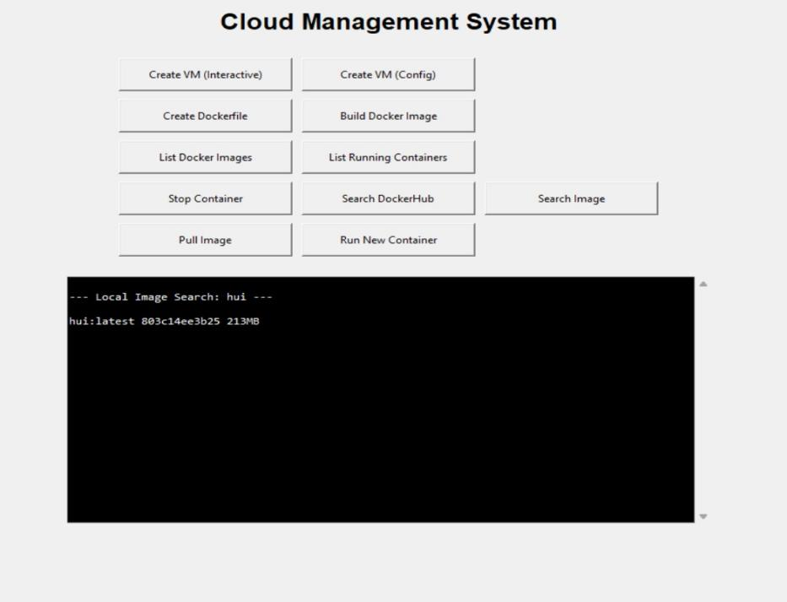
- VM launch with iPXE boot screen
- 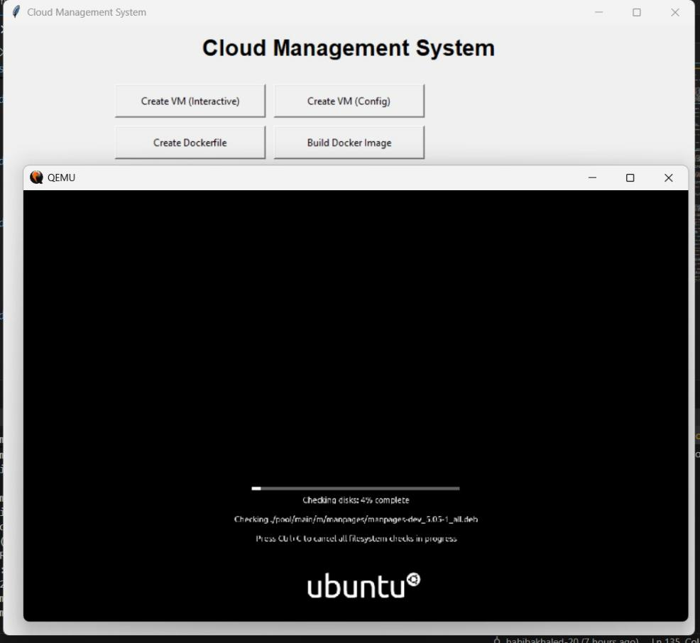
- Dockerfile creation success
- 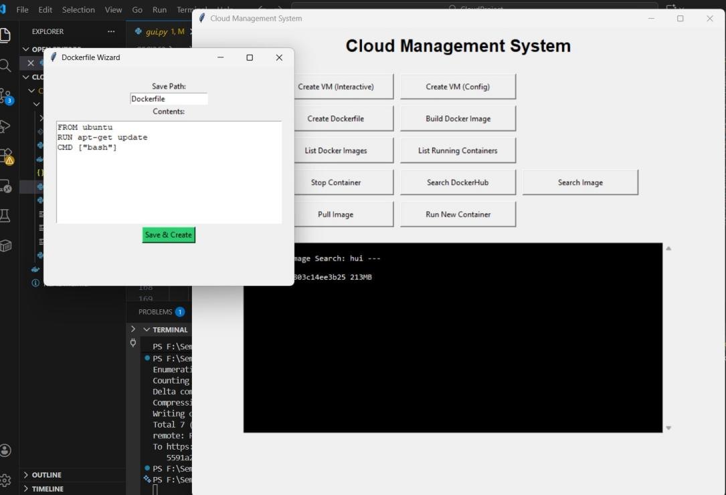
- Docker image build success message
- 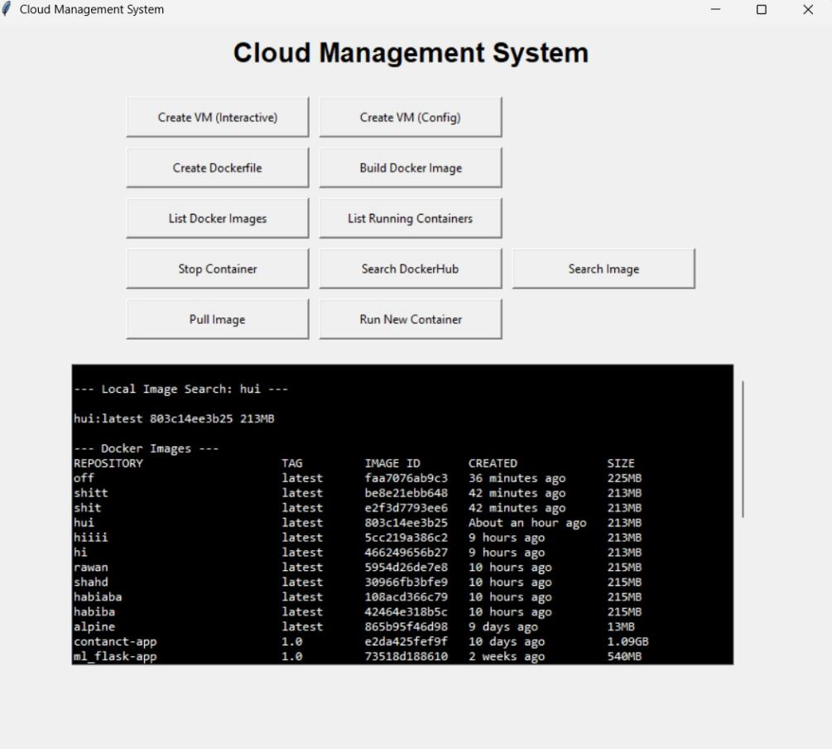
- Running container listing
- 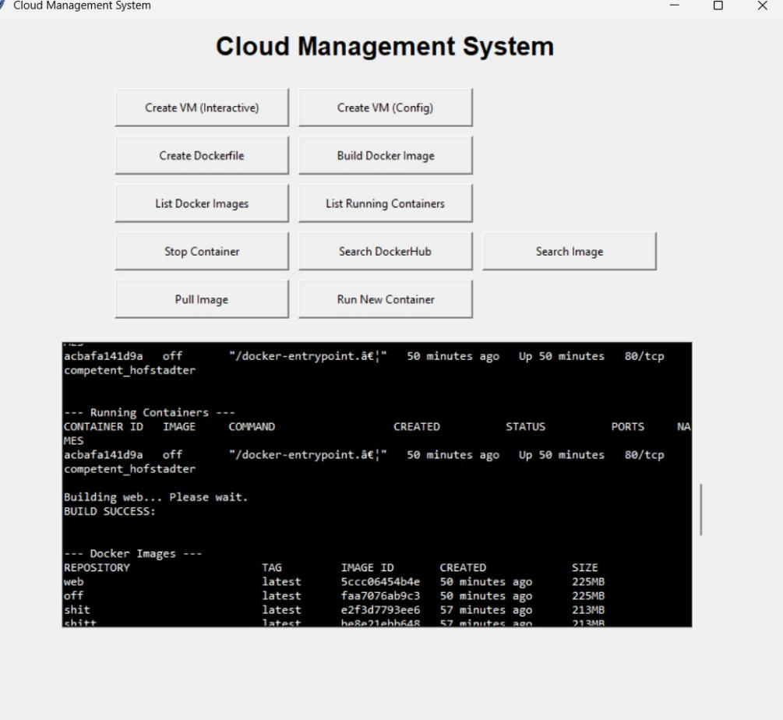
- Docker Desktop showing built images and engine running
- 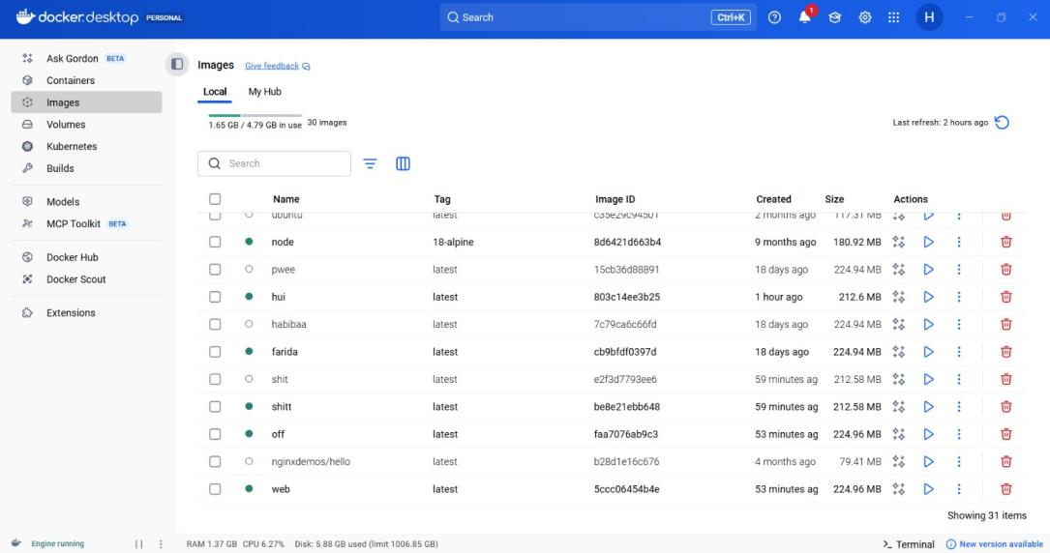
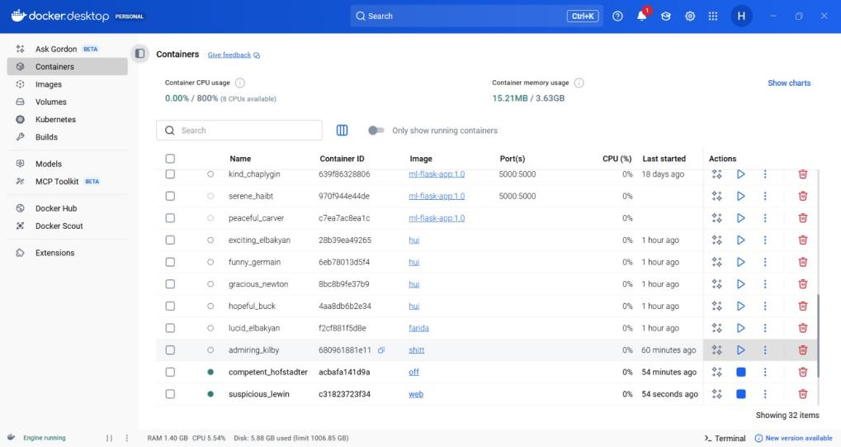

System Performance Evaluation
Performance Metrics
- VM Creation/Launch: Disk creation ~1–2 seconds, QEMU boot ~10–30 seconds (Windows TCG emulation)
- Dockerfile Creation: Instantaneous
- Docker Image Build: 5–20 seconds depending on complexity
- Docker Operations (list/pull/search): Sub-second to few seconds
- Container Start/Stop: Near instantaneous
Error Handling
- Comprehensive validation for paths, files, and user input
- Clear messages for missing files, Docker not running, etc.
Limitations
- Command-line interface (no GUI)
- Windows-specific QEMU graphics limitations (basic VGA mode)
- Dependent on external QEMU/Docker installations
Strengths
- Full implementation of all required objectives
- Robust Windows compatibility handling
- Modular, readable code with good error handling
- Reliable integration of QEMU and Docker CLI
- Lightweight and fast for standard operations

Conclusion
The Cloud Management System successfully implements all project objectives: VM creation (interactive and JSON config), Dockerfile creation, image building, and complete Docker management (list, pull, search, containers). Despite Windows-specific challenges with QEMU acceleration and graphics, the system reliably creates disks, attaches ISOs, launches VMs, and manages Docker resources.

